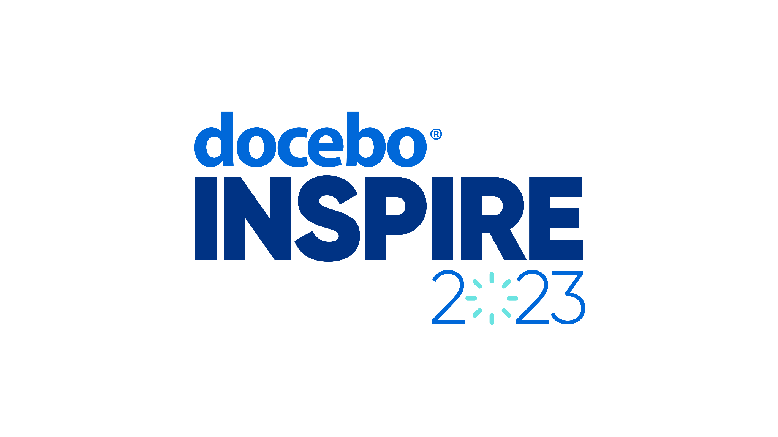Inspire 2023 “Convince the boss” Email Template

**Subject Line:** Requesting your approval to attend the Docebo Inspire 2023 Customer Conference

**Body:**

Hey (Boss Name),

I’m writing to request your approval for me to attend this year’s Inspire 2023 conference, hosted by Docebo in Nashville, Tennessee, September 18-20th.

As you know, we have invested a lot in Docebo as our Learning Management System (LMS), and their annual conference brings together their customers and L&D leaders from all over the world to learn, connect, network, and share cutting edge innovations and best practices.

There are 2 key benefits in me attending this event:

1. As an L&D leader, it’s important that I lead by example and continue to develop and improve my skills. By attending this event, I’ll have the opportunity to learn from some of the world’s most innovative learning leaders, and I will apply these insights to our learning initiatives here at (Company Name).
2. I’ll have the opportunity to meet with Docebo’s team of learning and technical experts, see the latest updates and features in their product, to make sure we are maximizing our investment in their LMS.

The total cost for me to attend this conference includes:

* **Airfare:** (Your city) to Nashville costs about $XXXX
* **Accommodation:** Three nights at the conference hotel is $1110.42 USD
* **Tickets:** A 3-day pass, including 1 day at Docebo University and meals is $899 USD (early bird rate)

Thank you for considering my request. I am more than happy to provide any additional information or address any concerns you may have. I look forward to your positive response and the opportunity to attend Inspire 2023.

* Sender Name